Data Mining

Name: Gurneet Chhabra

Date: 10-07-2021

Project Report

**Abstract:**

The problem is to implement two mining algorithms, Apriori and FP-Growth on the e Adult Census Dataset present in UCI ML repository. We also try to implement a variation of basic Apriori algorithm in order to improve its efficiency. We also generate the association rules in addition to the generation of frequent itemsets matching the confidence threshold mentioned.

Keywords

Pattern Mining, Apriori, FPGrowth, Association Rules, Naive Bayes, Adult Census Dataset

**1.Introduction**

Pattern mining is the process of extracting patterns from the datasets with the help of algorithms developed solely for this purpose. Frequent data mining involves extracting those patterns only which are frequent in the dataset that is which are above some threshold value.

The decision to when to consider a repeating pattern as frequent is based on a metric called “support”. Support can be looked as a frequency of occurrence of a particular itemset in the data. Support is a relative quantity. Once you mine the frequent itemsets, you can generate rules based on minimum confidence from these frequent itemsets. Using these rules, which are called ass association rules will help us to derive important insights from the dataset.

I applied the pattern mining approach discussed to Adult Census data from UCI ML repository.

Following tasks were performed:

(1) Implemented Apriori algorithm and applied it on the dataset. Applied the algorithm on whole dataset that is 32561 rows.

(2) Implemented FPGrowth algorithm and applied it on the Adult Census dataset. Applied the algorithm on whole dataset that is 32561 rows.

(3) Implemented an improvement of the Apriori algorithm and apply it on the dataset to improve the execution time of the classic Apriori approach. Applied the algorithm on whole dataset that is 32561 rows.

(4) Generated Association rules by passing an input minimum confidence level

(5) Comparative study of the above algorithms.

**2.Overview of Dataset:**

Adult Census dataset is taken from UCI ML repository.

The dataset consists of 32561 rows and 15 attributes. The 15 attributes of the dataset along with the values they take are as follows:

1. age: continuous.
2. workclass: Private, Self-emp-not-inc, Self-emp-inc, Federal-gov, Local-gov, State-gov, Without-pay, Never-worked.
3. fnlwgt: continuous.
4. education: Bachelors, Some-college, 11th, HS-grad, Prof-school, Assoc-acdm, Assoc-voc, 9th, 7th-8th, 12th, Masters, 1st-4th,
5. 10th, Doctorate, 5th-6th, Preschool.
6. education-num: continuous.
7. marital-status: Married-civ-spouse, Divorced, Never-married, Separated, Widowed, Married-spouse-absent, Married-AF-spouse.
8. occupation: Tech-support, Craft-repair, Other-service, Sales, Exec-managerial, Prof-specialty, Handlers-cleaners, Machine-op-inspct, Adm-clerical, Farming-fishing, Transport-moving, Priv-house-serv, Protective-serv, Armed-Forces.
9. relationship: Wife, Own-child, Husband, Not-in-family, Other-relative, Unmarried.
10. race: White, Asian-Pac-Islander, Amer-Indian-Eskimo, Other, Black.
11. sex: Female, Male.
12. capital-gain: continuous.
13. capital-loss: continuous.
14. hours-per-week: continuous.
15. native-country: United-States, Cambodia, England, Puerto-Rico, Canada, Germany, Outlying-US(Guam-USVI-etc), India, Japan, Greece, South, China, Cuba, Iran, Honduras, Philippines, Italy, Poland, Jamaica, Vietnam, Mexico, Portugal, Ireland, France, Dominican-Republic, Laos, Ecuador, Taiwan, Haiti, Columbia, Hungary, Guatemala, Nicaragua, Scotland, Thailand, Yugoslavia, El-Salvador, Trinadad&Tobago, Peru, Hong, Holand-Netherlands.
16. 16. class: >50K, <=50K

**3.Exploratory Data Analysis**

I have performed the EDA on Jupyter notebook and wrote the algorithm in Spyder IDE. Further created the plots in Jupyter notebook.

Preview of the dataset:

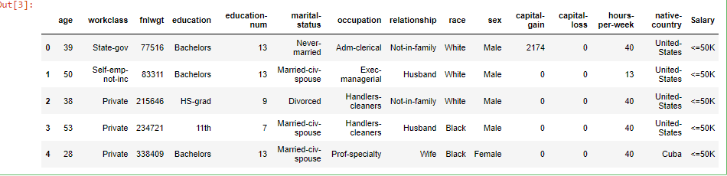

Fig 1. Displays first five rows of the data.

The basic statistics of the numerical column in the data is described below:

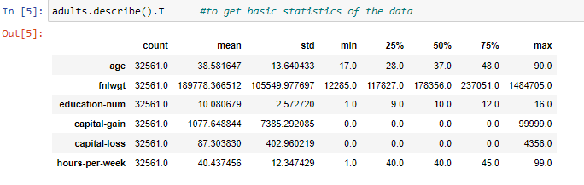

Fig. Statistics of the data given.

The dataset given has no null values. So we can say that there are no missing values in the dataset given.

But looking at the distribution of data, we can say that it is not a balanced dataset. It is biased towards one target class. This is evident from the categorical plot shown below:

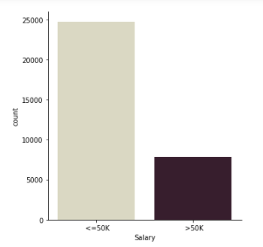

Fig: Value counts of each category

Existence of imbalance in the dataset.

* Percentage of rows with ’>50K’ : **24.1%** and
* Percentage of rows with label ’<=50K’ : **75.9%.**

The dataset also contains a mixture of continuous and discrete values.

The plots of “age”, fnlwgt“ , ”education-num”, “hours-per-week” are shown below.

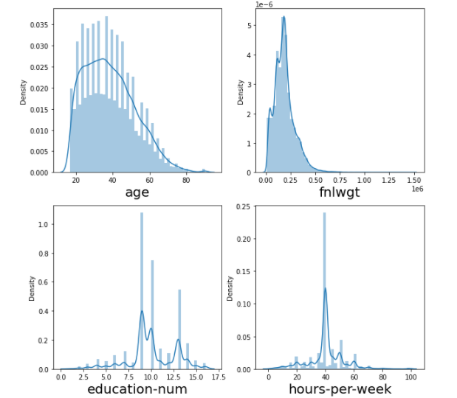

Fig. Distribution plots of various attributes.

**Observations**

1. The distribution of values of **age** are right skewed.
2. The distribution of values of **fnlwgt** that is of final weight are also right skewed.
3. We get a multimodel distributon for **education-num.**

**4.Preprocessing the Data:**

**Filtering out the attributes:**

The first task that I would do in pre-processing is remove the 'fnlwgt' attribute from the data.

The reason for removing the "fnlwgt" attribute is that it doesn't provide any information that would help us to determine if the person's income is greater than 50k. It only represents the weight that the row should have, which is defined by the censor takers. While we could have that weight in the dataset but it would complicate things, so I have decided to remove this attribute. Additionally, it is a numerical variable, so it would not make any sensne and we can just drop this attribute.

Similarly, other numerical attributes like "age", "hours-per-week" and "education-num" can also be dropped. Since these attributes are just numerical, we can drop them.

**Handling Missing Values**

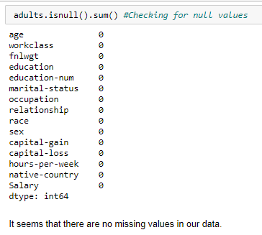

It seems that there are no missing values in the dataset.

Further I have also added prefix in front of the data values, that will enable to make distiction between the column value while generating frequent itemsets. The prefix is name of the attribute to which the data value belongs.

For example: values of "capital-gain" becomes "capital-gain : 0”, “white ”Value in race attribute becomes “Race: White”, and similarly modified allt eh values in the dataset. This would help us to easiy identify to which attribute the value belongs.

**5.Implementation:**

**5.1 Apriori:**

Apriori algorithm is used in data mining to generate frequent itemsets. It is one of the most basic Frequent Pattern Mining algorithm. Implemantation of Apriori is done by following the below algorithm which is mentioned in the textbook:

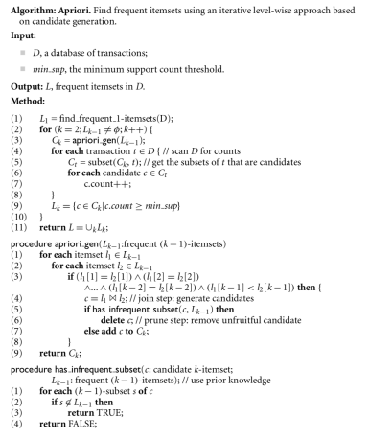

Fig. Apriori Algorithm

The key idea in Apriori is

* All subsets of a frequent itemset must be frequent Similarly, for any infrequent itemset
* all its supersets must be infrequent too.

The frequent itemsets generated by running the Apriori algorithm on 32561 rows resulted in generation of 63 frequent itemsets when minimum support is 0.5.

The itemsets generated are as follows:

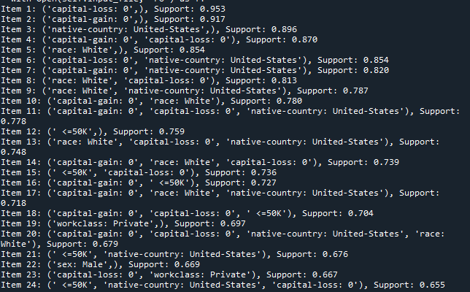

Fig: Number of frequent itemsets generated with min_support = 0.5

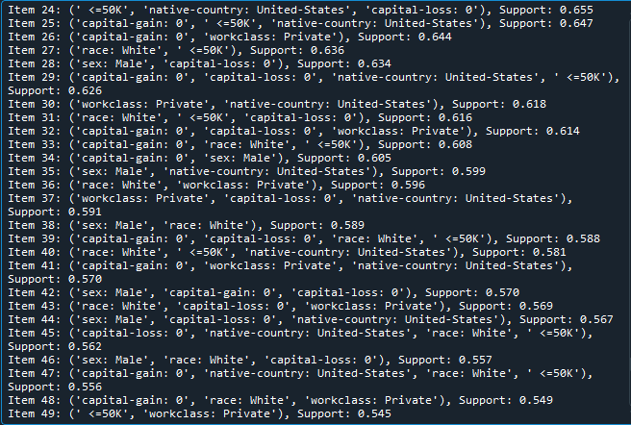Fig: Number of frequent itemsets generated with min_support = 0.5

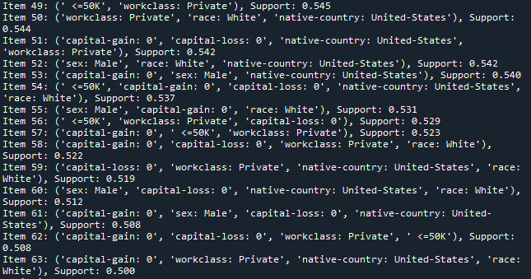

Fig: Number of frequent itemsets generated with min_support = 0.5

**Generating Association Rules**

Also I have implemented the code to generate the association rules. The number of association rules generated for minimum support of 0.5 and minimum confidence of 0.8 by running the algorithm on whole data is 177. The algorithm is executed oin whole daatset.

Some of the association rules generated are as follows:

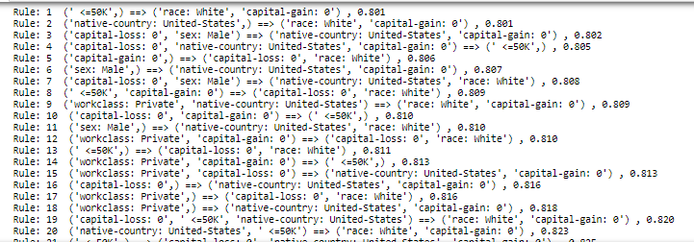

Fig. – Association rules generated.

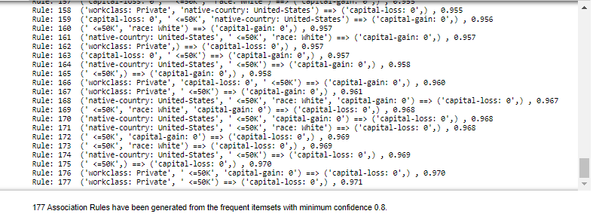

Fig. Association Rules Generated.

**Key Results for Apriori**

Here are the key results of running Apriori on the Adult Census Dataset with a minimum support of 0.5:

1. The total number of transactions in Adult.data = 32561
2. Time taken to generate the itemsets = 156.2239 seconds
3. Total number of itemsets generated = 63
4. Maximum itemset size = 5
5. Total number of association rules generated = 177

**Other Results:**

Further I ran the code for different values of minimum support and recorded the number of frequent itemsets generated and also the time taken to execute the code when run on whole dataset.

|  |  |  |
| --- | --- | --- |
| Support | No. of Freq Itemsets | Execution Time |
| 0.3 | 241 | 167.53 |
| 0.4 | 103 | 159.7026 |
| 0.5 | 63 | 156.2239 |
| 0.6 | 34 | 149.9687 |
| 0.7 | 18 | 116.9856 |
| 0.8 | 8 | 112.3324 |
| 0.9 | 2 | 103.8683 |

The same result can also be viewed graphically as:

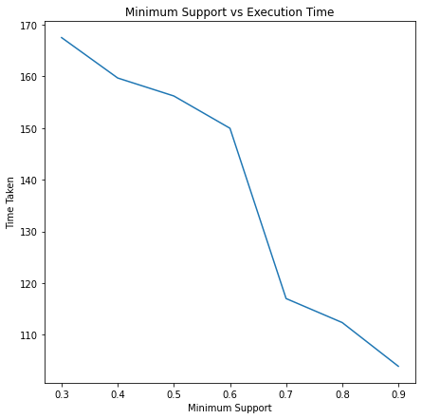

It is evident from the graph that as minimum support increases the execution time decreases.

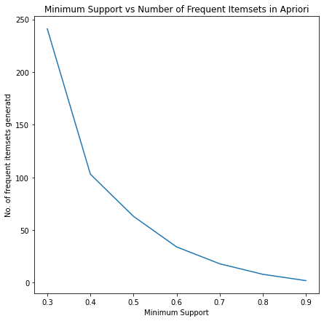

It is evident from the graph that as minimum support increases the the number of frequent itemsets generated decreases.

**5.2 FP-Growth:**

It is an scalable and efficient way of generating frequent itemsets.

This can be implemented by following steps:

1. Scan DB once, find frequent 1-itemset (single item pattern)
2. Sort frequent items in frequency descending order, f-list
3. Scan DB again, construct FP-tree
4. Construct the conditional FP tree in the sequence of reverse order of F - List –
5. Generate frequent item set

In FP- Growth the database is scanned only twice unlike Apriori. This reduces its execution time.

Output:

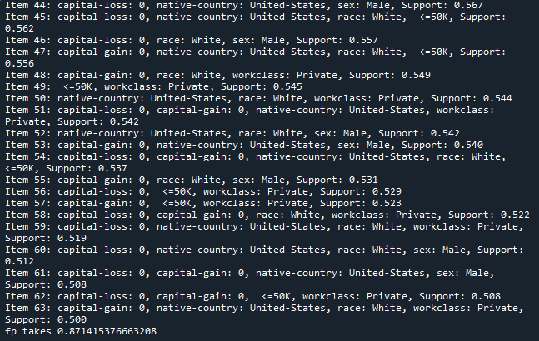

Fig: Time taken to generate freq itemsets for min support= 0.5

For this min_support= 0.5, 63 itemsets were generated same as Apriori.

**Key Results**

The key observations of the output are:

1. Total number of transactions in Adult.data = 32561
2. Time taken to generate the itemsets = 0.87 seconds This is much faster than Apriori for generating the itemsets on Adult.data.
3. Total number of itemsets generated = 63 (Same as Apriori)
4. Maximum itemset size = 5 (Same as Apriori)
5. Total number of association rules genereated will be same as that of Apriori as the number of frequent itemset sets are same.

The only two differences between Apriori and FPGrowth are that :

1. it generates the itemsets much quickly and
2. it scans the dataset only two times.

**Other Results:**

Further I ran the code for different values of minimum support and recorded the number of frequent itemsets generated and also the time taken to execute the code when run on whole dataset.

|  |  |  |
| --- | --- | --- |
| Support | No. of Freq Itemsets | Execution Time (in seconds) |
| 0.3 | 241 | 1.18 |
| 0.4 | 103 | 0.91 |
| 0.5 | 63 | 0.87 |
| 0.6 | 34 | 0.86 |
| 0.7 | 18 | 0.85 |
| 0.8 | 8 | 0.845 |
| 0.9 | 2 | 0.841 |

The same result can also be viewed graphically as:

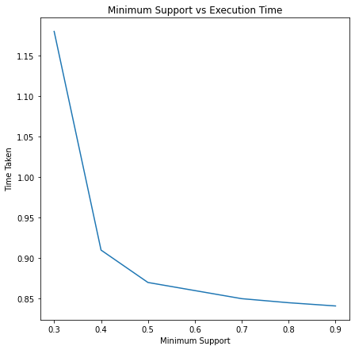

Fig. Minimum Support vs Execution Time FP-Growth

It is evident from the graph that as minimum support increases the execution time decreases.

**5.3 Improved Apriori**

Even though Apriori performed the desired task, but we still want to improve its efficiency, so that it takes less time to execute.

There are various ways to improve efficiency of Apriori. Some of them are lsited below:

1. Parallelization of itemset frequency check

2. Reduce the number of transactions scanned.

3. Hash-based technique

Here I am going to apply reduced transaction method.

Each transaction is associated with a Transaction ID. :

A transaction that does not contain any frequent k-itemsets cannot contain any frequent (k + 1)-itemsets. Therefore, such a transaction can be marked or removed from further consideration because subsequent database scans for j-itemsets, where j > k, will not need to consider such a transaction.

It only scan those transaction which have their ID in the transaction ID list and leaves the other transactions.

For a min_support= 0., it produces same number of frequrnt itesets as FP-growth and Apriori that is 63, when run on whole data of 32561 rows. The execution time is slightly better than Apriori.

**Key Results**

The key observations of the output are:

1. Total number of transactions in Adult.data = 32561
2. Time taken to generate the itemsets = 120.891 seconds This is much faster than Apriori for generating the itemsets on Adult.data.
3. Total number of itemsets generated = 63 (Same as Apriori)
4. Maximum itemset size = 5 (Same as Apriori)
5. Total number of association rules genereated will be same as that of Apriori as the number of frequent itemset sets are same.

**Other Results:**

Further I ran the code for different values of minimum support and recorded the number of frequent itemsets generated and also the time taken to execute the code when run on whole dataset.

|  |  |  |
| --- | --- | --- |
| Support | No. of Freq Itemsets | Execution Time |
| 0.3 | 241 | 151.95 |
| 0.4 | 103 | 137.37 |
| 0.5 | 63 | 120.891 |
| 0.6 | 34 | 110.63 |
| 0.7 | 18 | 105.211 |
| 0.8 | 8 | 102.36 |
| 0.9 | 2 | 96.36 |

The same result can also be viewed graphically as:

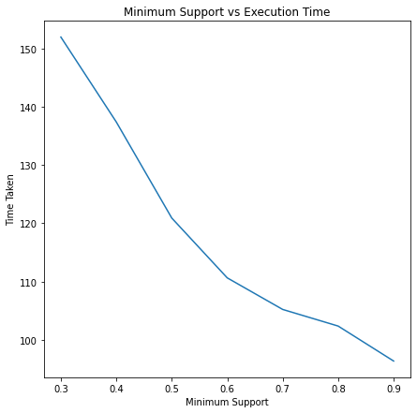

Fig. Minimum Support vs Execution Time FP-Growth

It is evident from the graph that as minimum support increases the execution time decreases.

**Comparative Study**

For a minimum support equal to 0.5:

* Apriori takes 156.2239 seconds
* Fp-growth takes 0.87 seconds
* Improved Apriori takes 120.89197 seconds.
* Clearly the execution time of FP-growth is much less than that of Apriori.
* The number of frequent itemsets generated by all three algorithms are equal .
* Also the association rules generated by all the algorithms are same.

Execution time for different minimum support whem the algorithm is executed on whole data, 32561 rows.

|  |  |  |  |
| --- | --- | --- | --- |
| Support | Apriori | Improved Apriori | FP-Growth |
| 0.3 | 167.53 seconds | 151.95 seconds | 1.18 seconds |
| 0.4 | 159.7026 seconds | 137.37 seconds | 0.91 seconds |
| 0.5 | 156.2239 seconds | 120.891 seconds | 0.87 seconds |
| 0.6 | 149.9687 seconds | 110.63 seconds | 0.86 seconds |
| 0.7 | 116.9856 seconds | 105.211 seconds | 0.85 seconds |
| 0.8 | 112.3324 seconds | 102.36 seconds | 0.845 seconds |
| 0.9 | 103.8683 seconds | 96.36 seconds | 0.841 seconds |

We can visualise the same result graphically as:

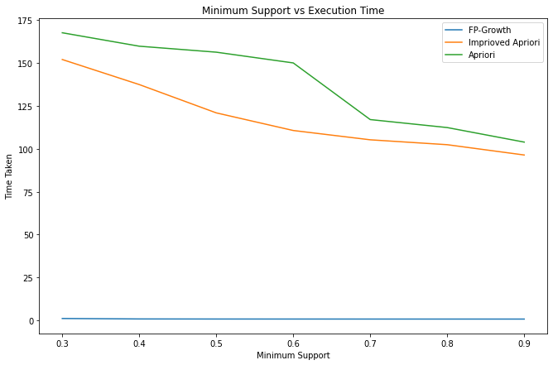

Fig. Comparative study.

In the above plot fp- growth shows a straight line as the the time taken by fp-growth alforithm is very much less than the time taken by the other two algorithms.

FP-growth algorithm is more efficient than Apriori. Following are the reasons to justify why FP-growth works better than Apriori:

* In FP-growth the database is scanned only twice, while Apriori scan the transactions for each iteration.
* It does not involve pairing of itemsets like in Apriori, so works faster than Apriori.
* FP- growth allows frequent itemset without candidate generation.
* FP- growth extracts itemsets directly from the FP tree and traverses through it.
* Execution time in FP-growth is lesser than Apriori due to absence of candidates.

**Conclusion**

We can conclude by the above results that FP-Growth works better way than Apriori. The number of frequent itemsets generated for a particular value of minimum support is same for both the algorithm. The execution time for FP-Growth is very much less than that of Apriori. Even though Apriori can be improved by changing its algorithm a bit, it cannot outperform FP-Growth. So, I conclude that FP- Growth is the fastest algorithm for generating frequent-itemsets.

**References**

[1] Jiawei Han, Jian Pei, Micheline Kamber Data Mining: Concepts and Techniques, 3rd Edition, Morgan Kaufmann